Web-Based Book Recommendation System Using Collaborative Filtering

Y.Chandana 1 Gajula Chenna Kesavulu 2, Bandela Mark Nicholas3, Shaik Mustak 4

1 Asst.Professor, 2, 3 & 4 Student

1[chandana.nrtnec@gmail.com](mailto:chandana.nrtnec@gmail.com), 2chennakesavulugajula@gmail.com, 3 marknicholasbandela@gmail.com, 4 mustakshaik@gmail.com

Department of Computer Science and Engineering,

Narasaraopeta Engineering College, Narasaraopet, Andhra Pradesh, India

***ABSTRACT- Recommender systems are essential for helping people make product recommendations and learn more about their online preferences. In the very competitive world of modern online booksellers, drawing clients and increasing sales effectively are essential. Of all the tactics, putting in place a referral system is one of the most effective. This study offers a clear and simple method for book suggestions, assisting readers in making the best choice of books. The suggested approach uses feedback-gathering and database training to provide insightful information for users to make decisions. This paper describes a recommendation system built with the collaborative filtering approach. Based on user choices, the system proposes and uses the KNN (k-nearest neighbors) machine learning (ML) model to categorize books. The suggested system's architecture.***

***KEYWORDS: KNN, Django, collaborative filtering, recommendation system, and book recommendation system***

# INTRODUCTION

# YouTube customizes video recommendations based on user queries and interests, while Netflix and Spotify offer individual movie choices. The availability of a certain book is quite important to bookworms, who will search across multiple platforms in order to find the books they want. People take a long time looking for books, reading them, and then making the purchase. Readers have different tastes in book genres, and it might be difficult for newcomers to identify what they are interested in [1]. A machine learning model is used to reduce the user's effort and expedite this process. The main objective of the Bok platforms is that users can now find information that suits their interests and preferences thanks to the invaluable tools that personalized recommendation systems have become.The recommendation System (BRS) is to offer readers a user-friendly interface where they can input their required books and search for the most favorite books[2].

# But even while these platforms accommodate users' choices for audiovisual and multimedia content, bibliophiles frequently have to navigate a disorganized environment in search of their next great read. Finding the ideal book requires searching through a variety of online stores, libraries, and book suggestion websites, which takes time and energy. In addition, the sheer variety of literary genres and titles may be too much for novice readers to handle, making it difficult to identify their interests.[3]

# In addition to making book browsing and selection easier, the BRS encourages accidental learning by introducing users to literature they might not have otherwise come across. Through the provision of a cohesive platform that combines book recommendations from many sources, the BRS offers users a smooth and engaging literary experience. preferences, making it easier for users to find their best books and related titles in a variety of categories on a one platform[4]. The goal of the BRS is to make book exploration and selection easier for users, giving them a smooth experience while they pursue their literary interests. In the current digital era, where people are consuming more and more information and entertainment online[5]

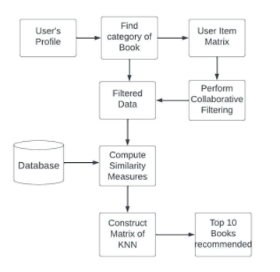

Fig 1. System Design

# 

# II.Related Work

The usefulness of recommender systems in sifting and providing [6] pertinent information is covered by T. Adi Lakshmi et al., especially with regard to audiobooks. To drive recommendations, a hybrid recommender system that combines collaborative and content-based filtering is presented.

The significance of user-specific recommendations is emphasized by Sarma Dhiman et al., with an emphasis on preferences and interests related to books. Various algorithms are used for effective book suggestions, including ECLAT and user-based collaborative filtering.

The application of machine learning models, such as boost, max voting, and KNN, for the purpose of forecasting different diseases[7] based on shared health records is covered by Choi Song Huin and Young Suin Jeiong et al in the healthcare arena. It is known that recommender systems have a wider application in information retrieval and business optimization.

III. PROPOSED METHODOLOGY

Machine learning has been used to create a Book Recommendation System (BRS) online application with an interactive chatbot. The website uses predicted user ratings and popular searches to help users choose books based on their choices [8]. The front end of the tech stack consists of HTML, CSS, JS, and Bootstrap. The back end uses Django and SQLite as its database. Book searches, account creation, and login are among the features that are integrated with Google's APIs..

*A. Dataset:*

The three tables in the dataset—Books.csv, Ratings.csv, and Users.csv—were taken from Kaggle and used in this paper. The book titles, authors, and ratings make up the dataset for the currently in use book recommendation system[10]. There are 6 columns and 271362 rows in the dataset. These represent the global standard for books. book title, book author, publisher, year of publication, and book image

­­­

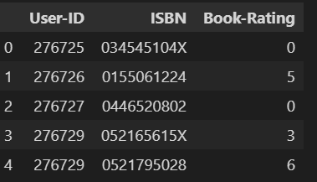

Fig 2. Rating Dataset

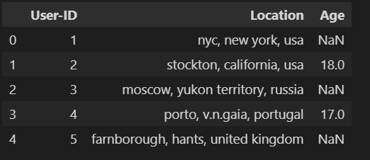

Fig 3. User Dataset

*B. Preprocessing Features:*

In order to improve computational performance and prevent "memory error," a preprocessing step is applied, wherein 1% of the total dataset is chosen for processing using the K-nearest neighbors (KNN) algorithm. After that, a 2-dimensional matrix is created from this reduced subset of data [11]. Zeros are used in place of missing values in the table to handle them. Furthermore, the rating values in the matrix data frame are transformed into a SciPy sparse matrix, guaranteeing calculations that are more accurate and resource-efficient.[11]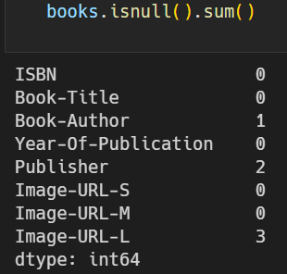

Fig 4. Dealing Null Values for the Books Dataset

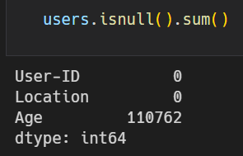

Fig 5. Dealing Null Values for the user's dataset

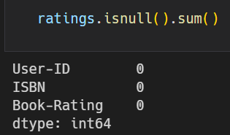

Fig 6. Dealing Null Values for the Ratings Dataset

*C. Model of the Architecture:*

This book recommendation system employs a hybrid methodology, integrating K-Nearest Neighbors (KNN) and collaborative filtering (CF) techniques to offer customers individualized book recommendations.

*1. User Interaction*:

The system offers a number of ways for users to engage with it, including book searches, genre browsing, and book ratings. [12] Data generated by this interaction is kept in a central database.

*2. Data Preprocessing:*

Preprocessing is done on the gathered data to guarantee its accuracy and consistency. This could entail addressing missing values, transforming the data into numerical representations, and eliminating superfluous information..

*3. Architecture:*

Hybrid Approach: By combining KNN and CF, one may take advantage of the advantages of each method, making it possible to adjust and adjust to various user profiles and sparse data. 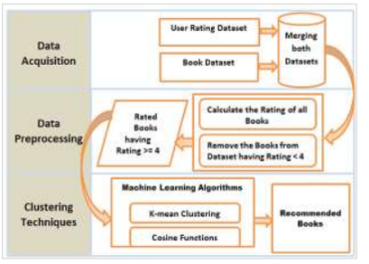

Fig 7. Proposed Technique for Book Recommendation

*D. Optimizer & Learn rate of the model:*

We employ the Adam optimizer in this project, which produces fast results for beginning learning levels at a rate of 0.001 for modern networks' network weights. [14] In this model, our initial learning rate is 0.001, which corresponds to the weights being in the frozen state. The learning rate is set to 0.0001 [7] after the model is constructed because it must learn the procedure and all of the weights are not frozen.

*E. Machine Learning Algorithm – KNN:*

use of the K-nearest neighbors (KNN) algorithm for genre classification in literature.[9] Using user reviews to generate customized book recommendations

*F. Visualization*

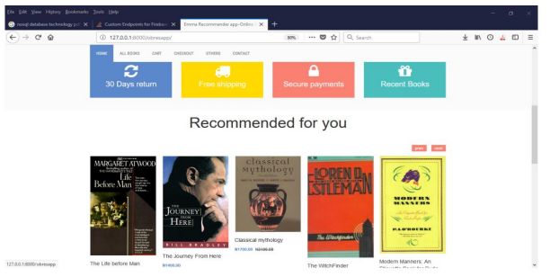

Fig 8..User Interface for the Customer

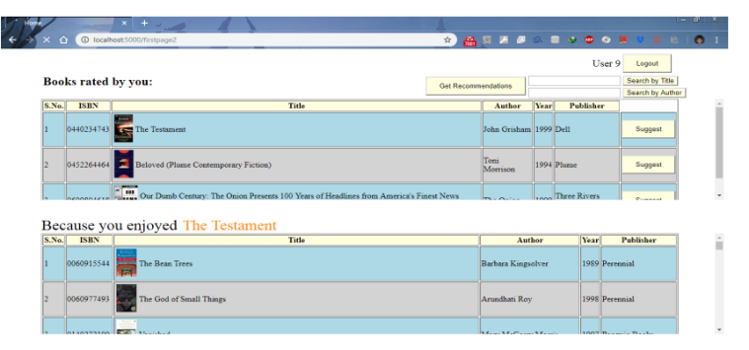

Fig 9. User Suggest books to others

*IV. PROPOSED MODEL PERFORMANCE*

*A. Dataset Distribution***:**

Here, we divide the dataset into categories based on the provided images: train, valid, and test. The whole image size is 89885. Here, 84635 picture data points are used for training purposes, and 2625 picture data points are used for testing purposes [13]. A small set of data will be used for validation once the data has been trained and tested. CNN is a sophisticated learning algorithm. In this case, the input picture identification is done using Xception and CNN. Here, we made use of the categorical mode and the three RGB hues. In the end, the measure of clump for creating and testing data is 64. We provided the information that was shown, which greatly improved our performance [14].

*B. Proposed Model Efficiency:*

Here, we set up the model for ten books, and we found that the accuracy of the information preparation was 87.26% and the accuracy of the information approval was 99.27% [14].After all of the testing and planning, the outcome was extremely accurate..

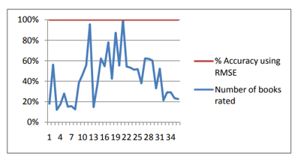

Fig 10. Graph of the number of books rated against the percentage accuracy of recommendation

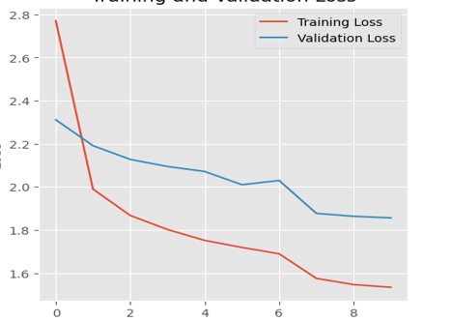

Fig 11. Train and validation loss

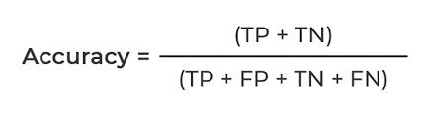

TN=” True positive”

TP=” True Negative”

FP=” False Positive”

FN=” False Negative”

Here we also calculated loss, and precision which all are evaluation metrics. [15]

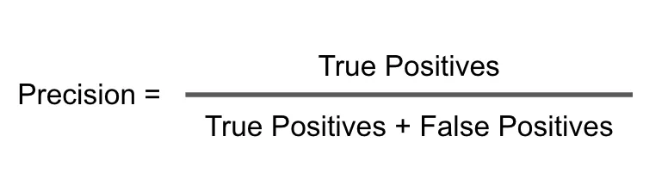

The frequency with which a machine learning model properly predicts the positive class is measured by a parameter called precision.

*C. Comparing Accuracy:*

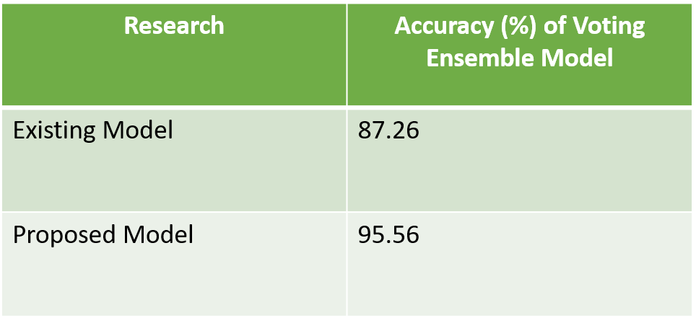

When we are using the existing model that is in the original base paper the accuracy becomes 87.26% and we are using the another model the accurate becomes the 95.56 % finally we conclude that we are changing the accuracy of the output from 87.26 to 95.26

*V. RESULT AND ANALYSIS*

A chatbot, Explore, Login/Signup, Book Search, and Popular Searches are some of the features available on the website interface.

The technique creates a sparse matrix for effective computation using a pre-processed dataset from Kaggle. KNN algorithms and collaborative filtering are used to make book recommendations based on user preferences.

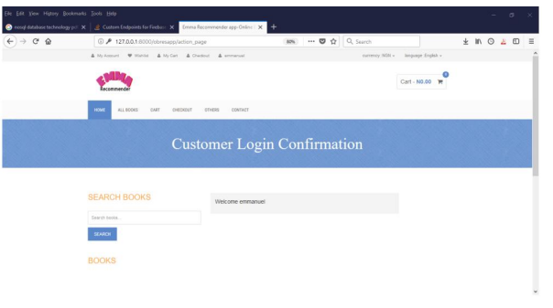

Fig 12. Login Page for the User

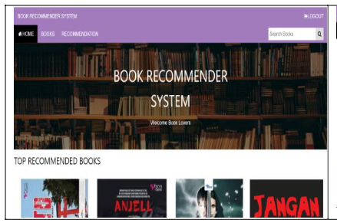

Fig 13. User Interface

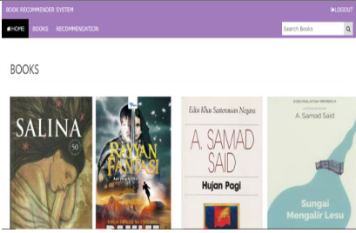

Fig 14.Recommended Books

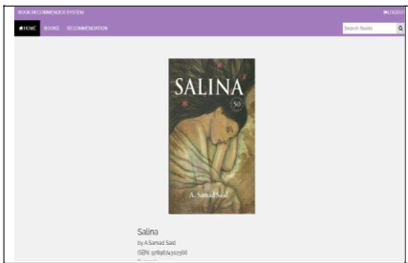

Fig 15.Detailed Book View

Table 1

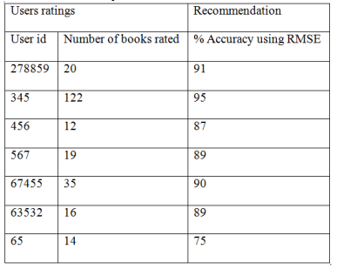

Table for user ratings and recommendations

*VI. CONCLUSION*

We have created a website specifically for the purpose of implementing a book recommendation system as part of this project. Personalized book recommendations are the main objective, and the collaborative filtering method is employed to achieve this. Additionally, a K-nearest neighbors (KNN) algorithm has been developed to categorize books according to a variety of characteristics, including authorship, genre, and narrative. Using the Dialogflow service from Google Cloud Platform, a chatbot has been added into the website to improve user interaction.

*VII. REFERENCES*

[1] Phorasim, Phongsavanh, and Lasheng Yu, "Movies recommendation system using collaborative filtering and k-means.”, International Journal of Advanced Computer Research 7, no. 29 (2017): 52.

[2] Kommineni, Madhuri, P. Alekhya, T. Mohana Vyshnavi, V. Aparna, K.

Swetha, and V. Mounika, ”Machine learning based efficient recommendation system for book selection using user-based collaborative filtering algorithm.”, In 2020 Fourth International Conference on Inventive Systems and Control (ICISC), pp. 66-71. IEEE, 2020.

[3] Mathew, Praveena, Bincy Kuriakose, and Vinayak Hegde, ”Book Recommendation System through Content-based and Collaborative Filtering Methods 2016 International Conference on Data Mining and Advanced Computing (SAPIENCE), pp. 47-52. IEEE, 2016.

[4] Choi, Sang Hyun, Young-Seon Jeong, and Myong K. Jeong, ”A hybrid recommendation method with reduced data for large-scale application.”,

IEEE Transactions on Systems, Man, and Cybernetics, Part C (Applications and Reviews) 40, no. 5 (2010): 557-566.

[5] Arulmozhivarman, M., and Gerard Deepak, ”OWLW: ontology focused user-centric architecture for web service recommendations based on LSTM and whale optimization.”, In European, Asian, Middle Eastern, North African Conference on Management Information Systems, pp.

[6] Lakshmi, Soanpet Sree, and T. Adi Lakshmi, ”Recommendation systems: Issues and challenges.”, International Journal of Computer Science and Information Technologies 5, no. 4 (2014): 5771-5772.

[7] Sarma, Dhiman, Tanni Mittra, and Mohammad Shahadat Hossain, ”Personalized Book Recommendation System using Machine Learning Algorithm.", "Personalized Book Recommendation System Using Machine

Learning Algorithm.”

[8] Kanetkar, Salil, Akshay Nayak, Sridhar Swamy, and Gresha Bhatia,” Web-based personalized hybrid book recommendation system.”, In 2014 International Conference on Advances in Engineering Technology

Research (ICAETR-2014), pp. 1-5. IEEE, 2014.

[9] Thorat, B., P., Goudar, RM Barve, S.(2015). Survey on Collaborative Filtering and Content-Based Recommending. International Journal of Computer Application, 110(4), pp.31-36.

[10] Bagul, D.V. and Barve, S., 2021, January. A novel content-based recommendation approach based on LDA topic modeling for literature recommendation. In 2021 6th International Conference on Inventive Computation Technologies (ICICT) (pp. 954-961). IEEE.

[11] S. S. Sohail, J. Siddiqui, and R. Ali, "Book recommendation system

using opinion mining technique," 2013 International Conference on Advances in Computing, Communications, and Informatics (ICACCI),

[12] A. S. Tewari, A. Kumar, and A. G. Barman, "Book recommendation system based on combine features of content-based filtering, collaborative filtering, and association rule mining," 2014 IEEE

International Advance Computing Conference (IACC), Gurgaon, 2014

[13] P. Mathew, B. Kuriakose and V. Hegde, "Book Recommendation System through content-based and collaborative filtering method," 2016 International Conference on Data Mining and Advanced Computing

(SAPIENCE), Ernakulam, 2016,

[14] Chih-Ming Chen "An intelligent mobile location-aware book recommendation system that enhances problem-based learning in libraries, Interactive Learning Environments", Journal Interactive Learning Environments, 2013,

[15] R. Rahutomo, A. S. Perbangsa, H. Soeparno, and B. Pardamean, "Embedding Model Design for Producing Book Recommendation," 2019 International Conference on Information Management and

Technology (ICIMTech), Jakarta/Bali, Indonesia, 2019

[16] S. B. Shirude and S. R. Kolhe, "Improved Hybrid Approach of Filtering Using Classified Library Resources in Recommender System," in Intelligent Computing Paradigm: Recent Trends: Springer, 2020[17] I. H. Sarker, A. Colman, and J. J. J. o. B. D. Han, "Recencyminer: mining recency-based personalized behavior from contextual smartphone data